Sinhgad Technical Education Society’s

SINHGAD ACADEMY OF ENGINEERING

Department of Computer engineering

Software Project Management

Lab Practice I (310248)

1. Create Project Plan

* Specify project name and start (or finish) date.
* Identify and define project tasks.
* Define duration for each project task.
* Define milestones in the plan.
* Define dependency between tasks.
* Define project calendar.
* Define project resources and specify resource type.
* Assign resources against each task and baseline the project plan………

1. Execute and Monitor Project Plan

* Update % Complete with current task status.
* Review the status of each task.
* Compare Planned vs. Actual Status.
* Review the status of Critical Path.
* Review resources assignment status.

1. Generate Dashboard and Reports

* Dashboard
* Project Overview
* Cost Overview
* Upcoming Tasks
* Resource Reports
* Over-allocated Resources
* Resource Overview
* Cost Reports
* Earned Value Report
* Resource Cost Overview
* Task Cost Overview
* Progress Reports
* Critical Tasks
* Milestone Report
* Slipping Tasks

### **Name :- Sham Anil Mane**

### **Class :- TE (B)**

### **Roll No. :- COTB13**

**Assignment 1**

**Food Order Management System**

**Title:** Create Project Plan

**Problem Statement:** Create Project Plan

* Specify project name and start (or finish) date.
* Identify and define project tasks.
* Define duration for each project task.
* Define milestones in the plan.
* Define dependency between tasks.
* Define project calendar.
* Define project resources and specify resource type.

**Requirements:** Project Management tools (any one tool from the list given below)

1. Edrawmax Project Management Software

**Theory:**

A Software Project is the complete procedure of software development from requirement gathering to testing and maintenance, carried out according to the execution methodologies, in a specified period of time to achieve intended software product.

A Project can be characterized as:

* Every project may have a unique and distinct goal.
* Project is not routine activity or day-to-day operations.
* Project comes with a start time and end time.
* Project ends when its goal is achieved hence it is a temporary phase in the lifetime of an organization.
* Project needs adequate resources in terms of time, manpower, finance, material and knowledge-bank.

Project Management is the presentation of knowledge, skills, tools and techniques to project activities to encounter the project requirements. Project management is proficient through the suitable application and combination of the project management process identified for the project. Project management permits organization to execute projects effectively and proficiently.

Edraw Max is 2D business technical diagramming software which help create flowcharts, organizational charts, network diagrams, floor plans, workflow diagrams, business charts, and engineering diagrams.

Here is how to use this tool for project management –

1. Open Edraw Max. Go to Files menu - Business – Project Management Tab.

You will see the screen like this:

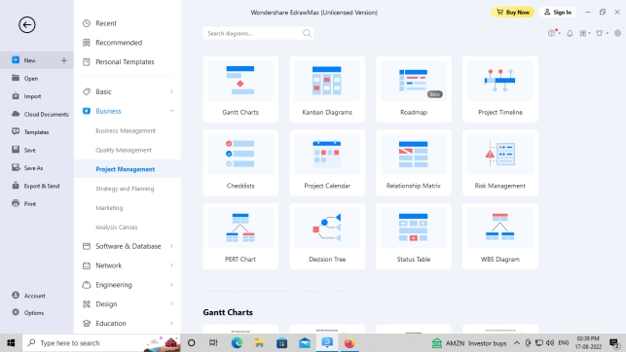

1. You will get options like Gantt chart, PERT chart etc. Select the chart type.
2. Drag and drop the format as per your requirement and you will get an auto generated table:
3. 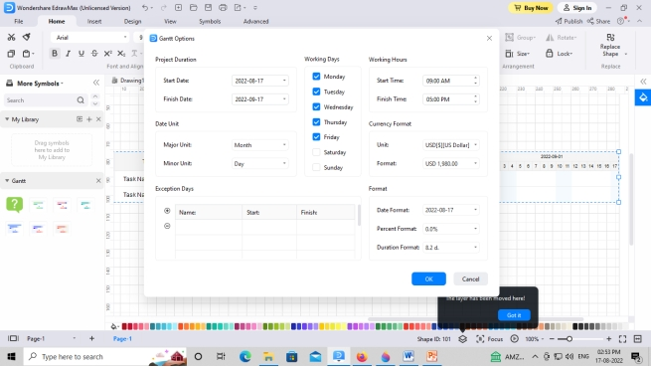

1. Fill up the required information. This includes start date, expected and date, resource allocation, weekly status and monthly progress.

1. You can edit and update the Gantt chart as you go on executing your project.

1. For PERT chart, go to File Menu – Business – Project Management – PERT chart.

1. Drag and drop PERT chart template as per your requirement.

1. Create nodes, dependencies, milestones and add schedules on the arrows.

1. The PERT chart screen sample:

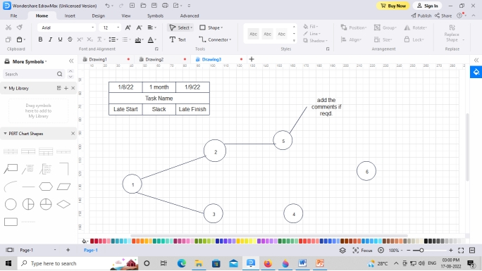

Food Order Management system is developed for the management of database. It is a browser based solution that designed to store, process, retrive and analyze information within Food Order Management System.

Purpose of project:-

1. To manage the data of Food Orders.

2. Fast delivery of food.

3. Food delivery management software automates delivery management.

Scope:-

The food ordering system these days has one of the fastest-growing markets, though being a new idea. In this project, we have developed something like the same to learn from and serve the nation in a much better way possible.

**Gantt Chart :-**

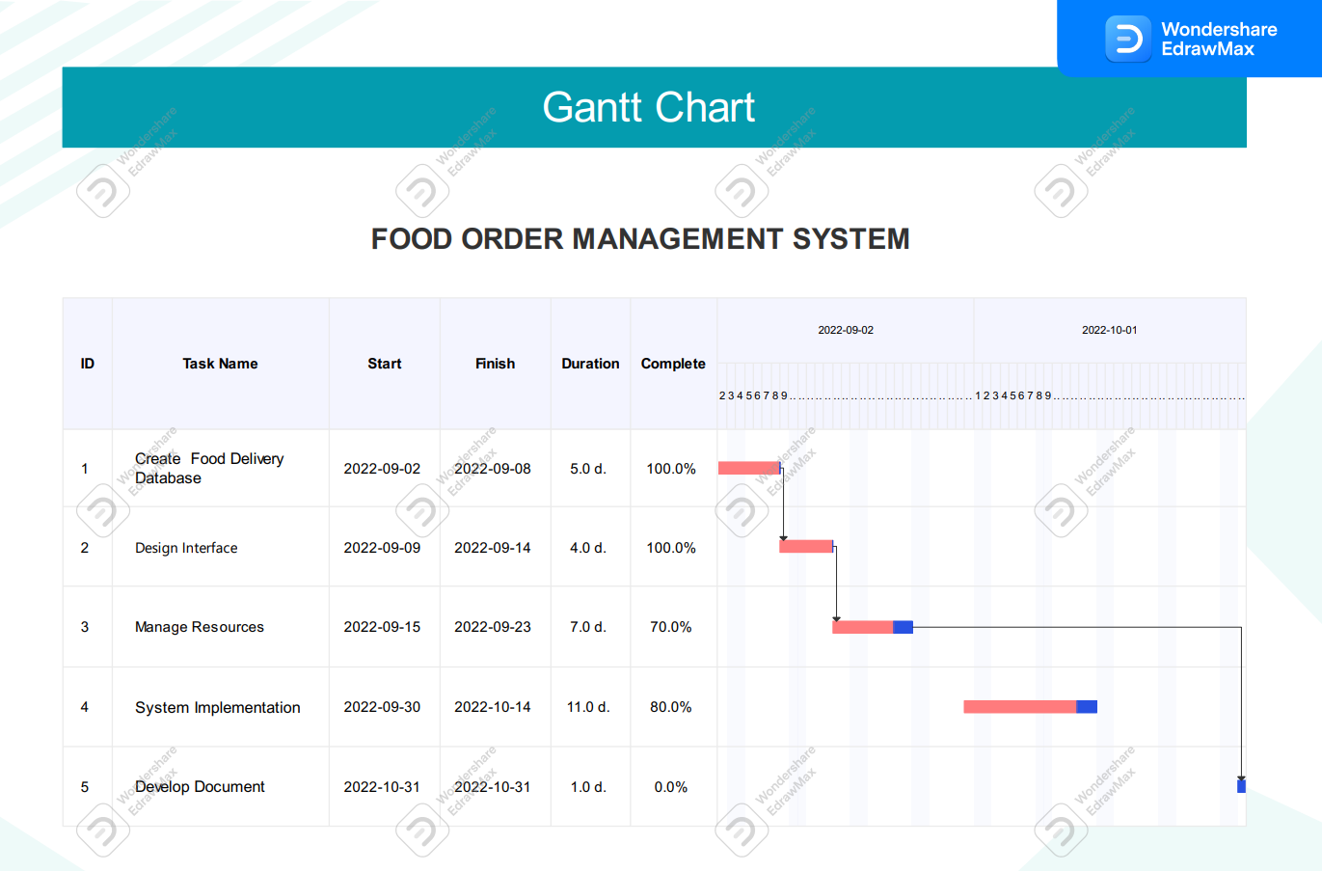

**Pert Chart :-**

**1.Network Diagram :**

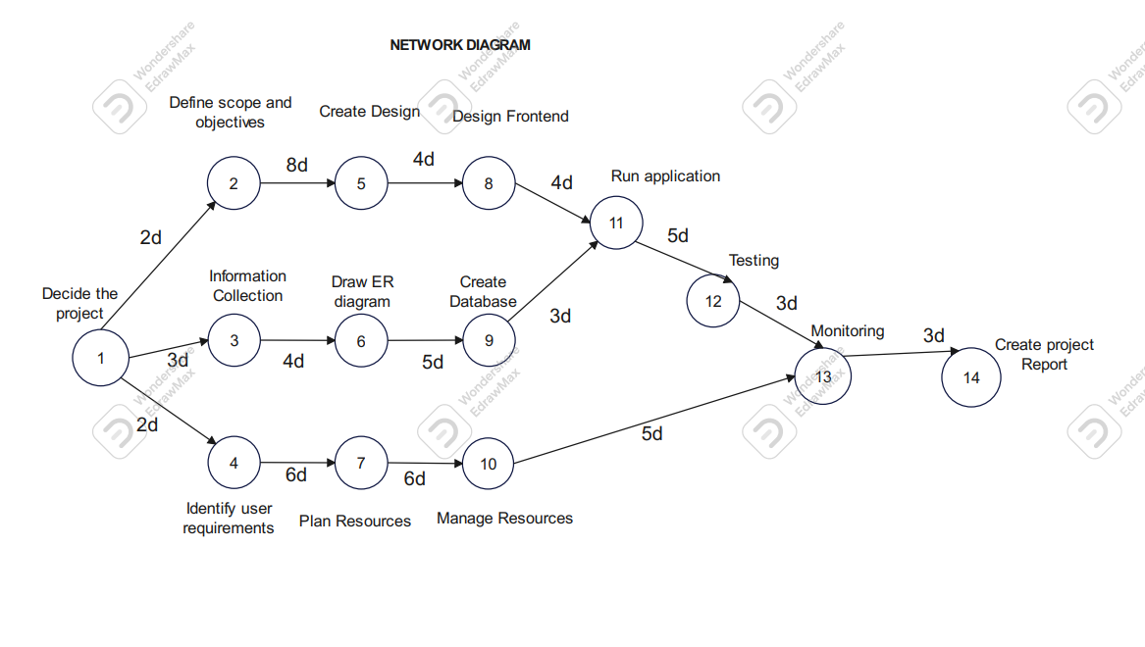

**2.Critical Path Method (CPM) :**

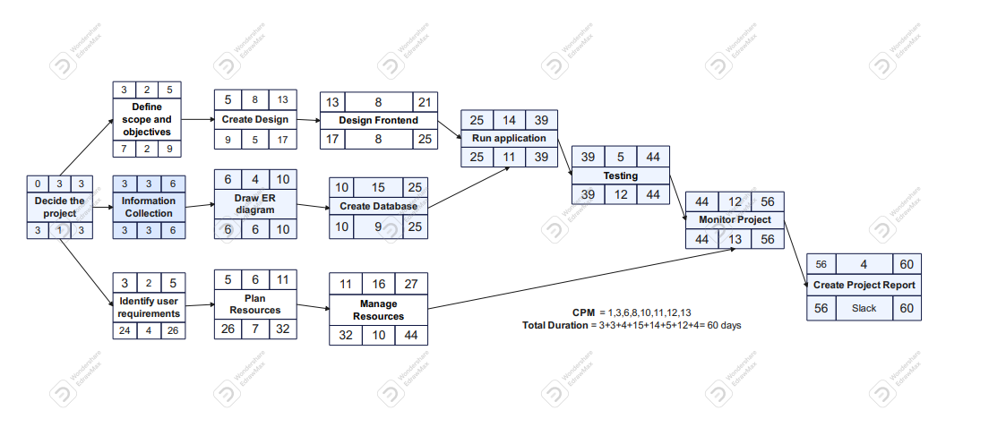

CPM= 1,3,6,8,10,11,12,13

Total Duration= 3+3+4+15+14+5+12+4=60 days

**Work Breakdown Structure (WBS) :**

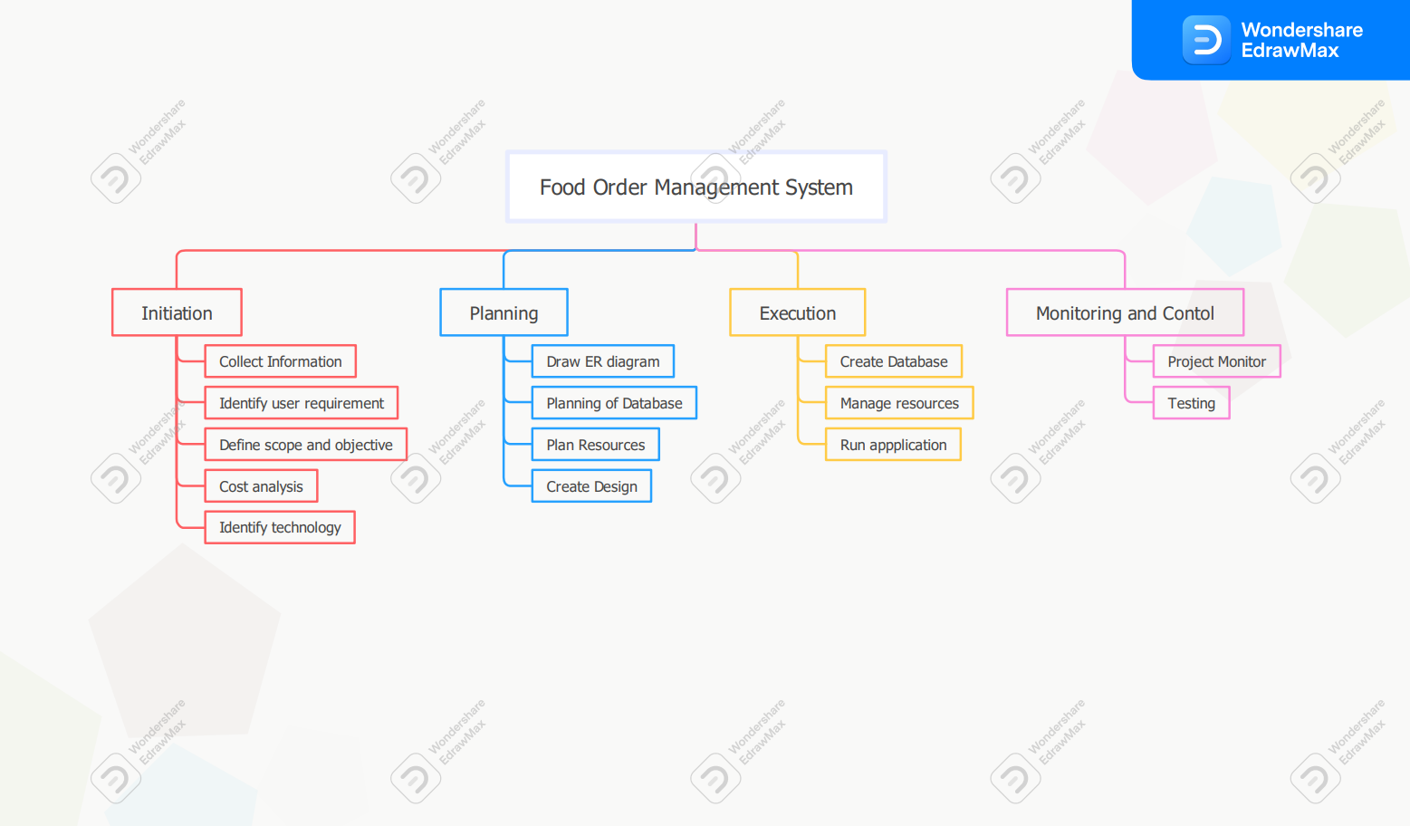

**Project Calendar :**

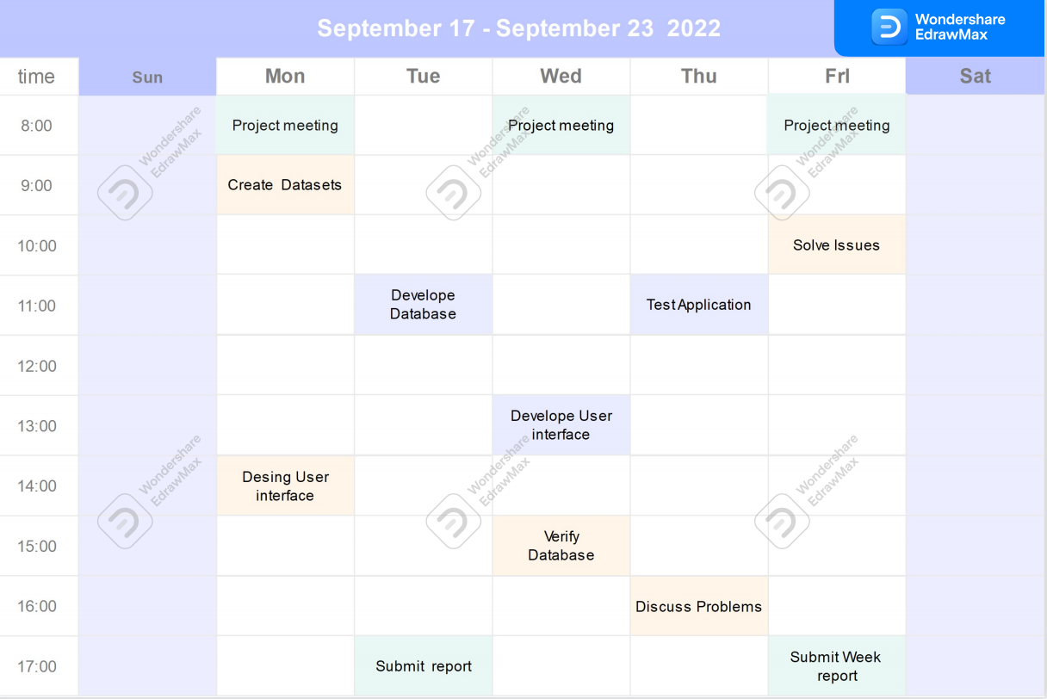

**Project Timeline :**

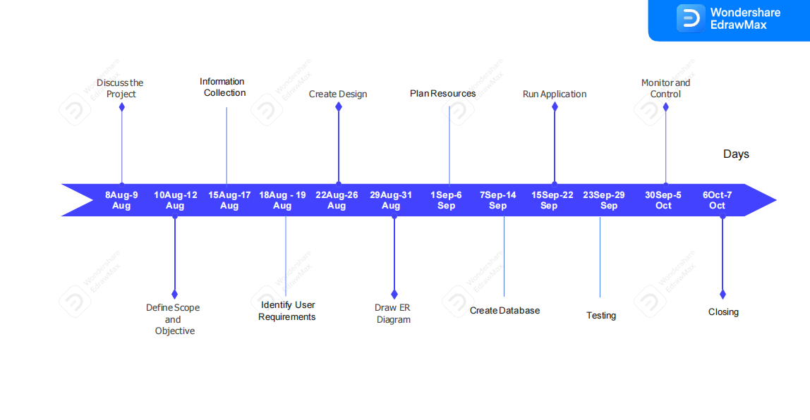

**Conclusion :**

This proposed Food Order Management System gives a reliable platform for both customers. Hence we are created the project plan.